Electromagnetic Principles and the Half Wavelength Dipole Antenna

Anthony Bommarito

March 2, 2018

**Abstract**

Antennas play a very important role in todays world dictated by the use of modern electronics. The need for antennas to become smaller to fit into laptops and personal cellphones, while also being more efficient so information can travel across vast distances seamlessly poses an engineering challenge. The purposes of this paper is to give an understanding on how electromagnetic phenomena describe an arbitrary antenna and then apply those principles to one of the most common antennas, the half wavelength dipole. Then advancements in dipole antennas will be discussed. This will allow for a brief understanding on how the devices people use every day are able to transfer and receive information.

Wireless antennas are a critical piece to modern communication. They are designed to radiate or receive electromagnetic waves. They act to transduce guided waves into free space waves or change free spaces waves into guided waves. The advent of antennas was allowed by the formulation of maxwells equations in 1873, however the first signal sent over a large distance did not occur until 1901. Modern advancements such as waveguides did not occur until WW2 and beyond [3].

The process of radiation is a critical component in describing how antennas work. To understand how radiation works, first consider a single conducting wire with charge density $ρ$, and cross sectional area $A$. The charge moves in the $x$ direction with velocity $v$. We then know the current density is given as $J=ρv$. If the wire is allowed to be very thin, this approximates our wire as a line of charge, then current is $I=λv$, where $λ$ is the amount of charge per unit length. In antennas, the source typically provides an alternating voltage, thus an alternating current. It is then natural to see how the current changes with time, thus $\frac{dI}{dx}=λa$, where a is the acceleration of the charges. This result is the “fundamental relation of electromagnetic radiation”. Result shows that in order to have radiation, we must have a time varying current [1]. Taking this one step deeper means our charges must be accelerating. These accelerations are typically produced by the bending of wire in a typical antenna.

A typical antenna consists of more than one wire, but the mechanism explained is similar. If we consider two wires, one positively charged and the other negatively charged lying parallel to each other connected to the same voltage source, applying a potential difference across the two wires will cause an electric field between them. This electric field will then cause the charges to begin to displace; creating a current. This current will then create a magnetic field, and if the source of the voltage is an alternating source it will produce both a time varying electric and magnetic field. This process follows from Maxwell’s equations:

(1) $∇⋅E=\frac{ρ}{ϵ_{o}}$

(2) $∇×E=-\frac{dB}{dt}$

(3) $∇⋅B=0$

(4) $∇×B=μ_{o}J+\frac{1}{c^{2}}\frac{dE}{dt}$

Equation (1), or Gauss’ law, tells us that an electric field will exist due to the distribution of charges. It can be solved to show that the field is non-zero. Amperes’ law, shown in equation (4), tells us that a current will cause a magnetic field. Since we know that the source is varying with time we also know that the electric field will vary with time. Maxwell’s corrections to (4) shows that a varying electric field will give rise to a magnetic field. Equation (2) shows that a varying magnetic field will give rise to an electric field [2]. These time varying fields are what gives rise to the electromagnetic radiation that antennas transmit or receive.

**Radiation Formalism:**

Electromagnetic radiation can travel through space as a wave. A common antenna is the half wavelength dipole antenna, but before we can understand how that works we must understand how radiation is created and the mathematical formalisms that describe it. First, consider some sphere of charge with radius $r$, and solid angle $Ω$. Doing this will allow us to describe the power radiated due to an arbitrary shape.

If there was to be some form of electromagnetic radiation then, $dP(t)=\lim_{r→∞}\overset{̂}{r}⋅S(r,t)r^{2}dΩ$ must be satisfied and be nonzero. Moreover, the Poynting vector, $S=E×\frac{B}{μ_{o}}$ must be nonzero [2]. From this limit definition, it is implied that $S∼\frac{\overset{̂}{r}}{r^{2}}$ as $r$ tends to infinity. This means that in order to have any sort of radiation, then $E$ and $B$ must both go like $\frac{1}{r}$.

The total power is then the surface integral taken over the entire sphere,

$P(t)=\lim_{r→∞}∫_{A}dA⋅S$

This can be rewritten using Poynting’s theorem:

$$\int_{A}{dA⋅S+}$$

Rearranging this:

$$-∫_{V}d^{3}rj⋅E=P(t)+\frac{dU}{dt}$$

This shows that the total power can be found by computing the integral on the left. By taking the timed average of this equation we get [4]:

This integral is computed often by antenna engineers, because it gives the average power produced by an electromagnetic wave when it gets far from the source.

With this formalism out of the way, let us consider the case of electric dipole radiation. Suppose we have two metal spheres that are connected by a wire of length $d$. Charge is allowed to flow through the wire such that, $q(t)=q_{o}cos(ωt)$. This assures that there is a varying current, and thus radiation. The potential can then be found using [2] :

Here, $ρ$ is the current density and $R$ is the separation vector and $t_{R}=t-\frac{R}{c}$, is the retarded time. The use of the retarded time is necessary, because we are interested in the source at the time the signal was sent.

Similarly the vector potential $A$ is given as [2]:

In order to find E and B we use what are known as Jefimenko’s Equations:

$$E=-∇V-\frac{∂A}{∂t}=\frac{1}{4πϵ_{o}}∫\frac{ρ(r^{′},t_{R})}{R^{2}}\overset{̂}{R}dτ^{′}+\frac{1}{cR}\frac{∂ρ(r^{′},t_{R})}{∂t}\overset{̂}{R}dτ^{′}-\frac{1}{c^{2}R}\frac{∂J(r^{′},t_{R})}{∂t}dτ^{′}$$

$$∇×A=B=\frac{u_{o}}{4π}∫[\frac{J(r^{′},t_{R})}{R^{2}}+\frac{1}{cR}\frac{∂J(r^{′},t_{R})}{∂t}]×\overset{̂}{R}dτ^{′}$$

Once we know both E and B, we can then compute the power radiated by our dipole configuration [2]. For the configuration described above the average power is given as, $<P>=\frac{u_{o}q_{o}^{2}d^{2}ω^{4}}{12πc}$

**Half Wavelength Dipole Antenna**

Armed with a basic understanding of radiation theory, we can now take a look at simple antenna model. An important type of antenna is the half wave dipole antenna. Dipole antennas are used in most modern communication devices, such as cell phones. Another example of a dipole antenna is the “rabbit ears” on old television sets.

A typical dipole antenna consists of two parallel conducting rods. This antenna is discontinuous at $l=π/4$. This follows from the fact that it is a half wave dipole antenna, so the current flows from : $λ/2<l<λ/4$ and $-λ/4<l<λ/2$. Let us assume the current is driven by some sinusoidally varying source, such that the current goes like $I(y)=I_{o}cos(βy)$.

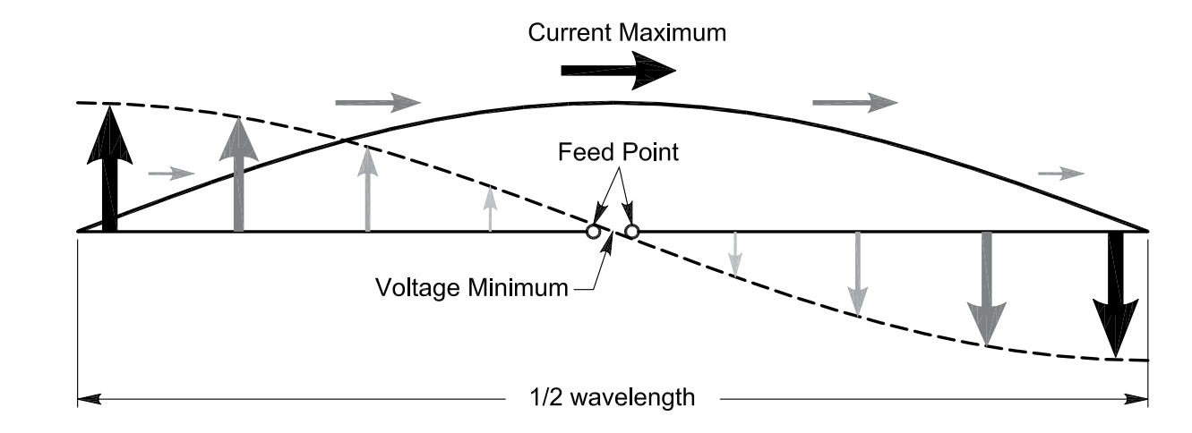

**Figure 1:** A plot of the current and voltage in a $\frac{λ}{2}$ antenna (Donovan)

As can be seen, the current reaches some maximum value $I_{o}$ at $x=\frac{λ}{4}$ and falls off to zero at the ends of the antenna. Conversely, the voltage is a minimum at the center of the antenna and reaches its maximum value near the ends of the antenna. If the feed is taken as the zero point it can be seen that the current leads the voltage because it peaks first.

The electric field this current produces in space is of importance. Let us cut our antenna into small slices with length $dy$. Next, to find the electric field at a point $p$ away we use the principle of superposition and sum up all the contributions of the electric field caused by the dipoles in the antenna. The far field is a well known result [5]:

If we want the field caused by our antenna we must integrate this expression, it then becomes :

$$dE_{θ}=\frac{I(y)dyiωμexp(-ikr)sin(θ)}{4πR}$$

Where $R$ is the distance from the antenna length element and point *p*, $r$ is the distance from the origin ($λ/2$) to point *p*.

When we get very far away from the antenna,

$\frac{1}{R}=\frac{1}{r}$

This is because the two vectors are approximately parallel. When the integral is then computed, the electric field is found to be

$E_{θ}=\frac{iωμIexp(-ikr)sin(θ)}{r}$ $\frac{cos(π/2cos(θ))}{k\sin^{2}(θ)}$

An important comment to make is that the field goes like $1/r$. This follows the discussion made above. Knowing the electric field we can now compute the power that is radiated, but we first need to find the potential energy, which is:

$$U=\frac{ωμI^{2}\cos^{2}(π/2cos(θ))}{8kπ^{2}\sin^{2}(θ)}$$

The power is then found to be:

$$P=∫_{0}^{π}∫_{0}^{2π}Usin(θ)dϕdθ$$

This can be computed numerically, the value is found to be $P=36.5640I^{2}$. The larger the magnitude of the current, the larger the radiated power [5].

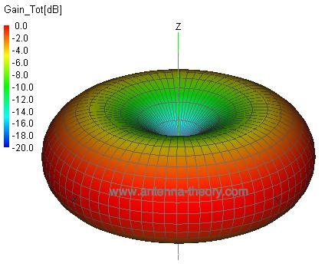

**Figure 2**: 3-D visualization of power radiated by $\frac{λ}{2}$ dipole antenna (Bevelacqua)

The power radiated from the antenna is symmetric about the axis of the dipole. At the axis the power radiated is zero. It can also be seen that the power is a maximum at points perpendicular to the dipole. This is the reason why these antennas are so commonly used; they allow for radiation in all directions in space, which is useful when we have things such as cellphones and other devices that are not used in one fixed location in space.

**Advancements**

Now that there is an understanding of mathematical analysis of a simplified antenna model, let us look at an important advancement in the field. Advancements in antenna theory will allow for more efficient communication and the progression of most modern devices.

One major advancement in the field of antenna theory is the dual frequency dipole antenna. This type of antenna has an application in personal communication devices such as laptops. This antenna allows for radiation to be transmitted and received, which is necessary for the efficient flow of information. Advantages of this antenna is that it is small allowing it to fit within a laptop, where as older models, such as the monopole antenna were very large and protruded from the device. This antenna is realized by having one large dipole designed for smaller frequencies and one short dipole designed for larger frequencies [6].

In order to have a high gain, the antenna is roughly $1λ$ long. When current with low frequency is introduced the current flows to the short dipole and then couples to the larger dipole, enduring radiation. When high frequency current is introduced the current only flows through the short dipole, inducing radiation. It is the job of the engineer to make sure the dipoles are spaced out far enough such that the high frequency current does not couple to the large dipole. Another issue is making these antennas affordable. This is being done by 3D-printing out the antennas components [6].

**Conclusion**

The study of antenna theory is important for the progression of the technological age. Although the half wave dipole model is rather simple, it presumed some mathematical sophistication, which stem from first principles (Maxwell’s equations). Having a basic understanding on how the simplified model works will aid in the understanding of more complex systems that have application in every day life. Advancements in the field of antenna theory are important to ensure technology will continue to evolve; giving rise to more efficient communication devices and much more.

**References**

[1] Balanis, C.a. “Antenna theory: a review.” *Proceedings of the IEEE*, vol. 80, no. 1, 1992, pp. 7–23., doi:10.1109/5.119564.

[2] Griffiths, David J. *Introduction to electrodynamics*. Cambridge University Press, 2018.

[3] Balanis, Constantine A. *Antenna theory*. Harper & Row, 1982.

[4] Zangwill, Andrew. *Modern Electrodynamics*. Cambridge University Press, 2013.

[5] Hum, Sean V. University of Toronto, [www.waves.utoronto.ca/prof/svhum/ece422/notes/07-halfwave.pdf](http://www.waves.utoronto.ca/prof/svhum/ece422/notes/07-halfwave.pdf).

[6] Low cost microstrip-fed dual frequency printed dipole antenna for wireless communications.Suh,Young-Ho et al.Electronics Letters(2000),36(14):1177

Figure [1]: Donovan, John (2012), <https://www.digikey.com.au/en/articles/techzone/2012/nov/selecting-antennas-for-embedded-designs>

Figure [2] Bevelacqua, Joseph, Peter http://www.antenna-theory.com/basics/radpattern.php